This blog discusses briefly the gene expression data recently analyzed and charted on Tableau regarding COVID-19. At first I thought it was actual treatment and control case studies on COVID-19. But it is actually a study that shows how eliminating the effects of IL6 a cytokine seen to cause lung inflammation in COVID-19 can be demonstrated by testing the effectrs of an IL6 inhibitor used in Rheumatoid Arthritis (RA) patients' whose autoimmune disorder produces that same abundance of IL6 that makes their disease painful.

The data and study can be found at https://www.ncbi.nlm.nih.gov/geo/query/acc.cgi?acc=GSE151161 where the text and csv files for the series matrix information with RAW data can be downloaded. The scripts I ran with my coding was done in Rstudio and used some of my previous R functions for getting gene summaries and finding top scored genes for disorders searched into genecards.org. Those files can be found at my github account: <https://github.com/JanJanJan2018/RA-simulating-COVID-study-analysis>.

A brief summary of this study was that in the last few months of this year between May and July 2020, 38 patients, of which 32 were femals and 6 were males aged 21-80 years old all suffering from RA, had their blood drawn at week 0 and at week 12. Week 0 is the control and was given Abatacept to inhibit IL6, then 12 weeks later the blood from the same patients was drawn again and given Abatacept. The gene expression profiles were taken for week 0 and for week 12. This was the study design. Changes in the gene expression values between mean samples at week 0 and at week 12 were not very noticeable. There were some changes between age and gender classes and for certain genes. The genes totalled 56,638, with only two genes have copy number variants. The means of each gene were taken, then the means from within each set of control or treatment. Also, within the control and treatment groups the mean gene expression values were taken for females in control and in treatment, then the males in control and in treatment, then by age groups of those younger than 50 for the control and treatment, and for those 50 or older for control and treatment. From those mean values, the fold expression for changes in the ratio of treatment to control were calculated. For the visualizations, the log scale base 2 was used for scaling down outliers and making the visualization appear more uniform. The genes shown are 42 genes that were in at least one of the top 25 genes found when entering health systems or diseases into genecards.org with the find25genes function created in previous scripts. Some genes were in two or more diseases, and some in all three, while some in only one. The systems searched were, immunity, rheumatoid arthritis, and serous fluid.

All images are linkable screen shots of the Tableau interactive charts that show more details when hovering over each scatter or bar on the chart.

<https://public.tableau.com/profile/janis5126#!/vizhome/RAsimulatedCOVID19/RAsimulatedCOVID19?publish=yes>

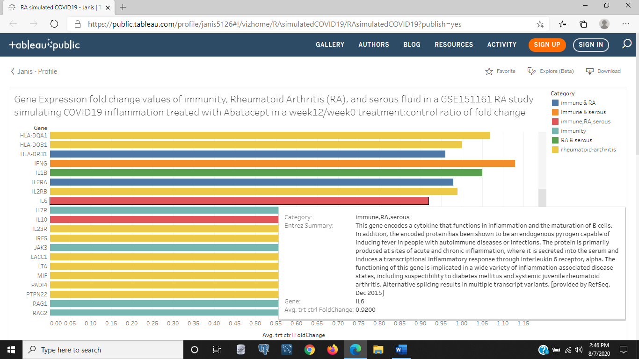

Figure 1a: The image above is a screen shot of the Tableau bar chart that shows the overall comparison of the treatment of 12 weeks with Abatacept to the control of 0 weeks with Abatacept for Interleukin 6, IL6, a cytokine that can cause fevers and is in all three searched health and disease systems of immunity, serous fluid found in body cavities that separate organs and protect them, and in RA of which all the particiapants in this study suffered from the autoimmune disease RA. There was a noticeable decline of 8% average in the production of IL6 after 12 weeks compared to 0 weeks of being treated with Abatacept that inhibits IL6. That was the hypothesis of the study this data was derived, so that they could show treating patients suffering with the same disease symptoms of lung inflammation could slow down the inflammation with Abatacept. The most expressed gene after 12 weeks compared to 0 weeks in the above chart

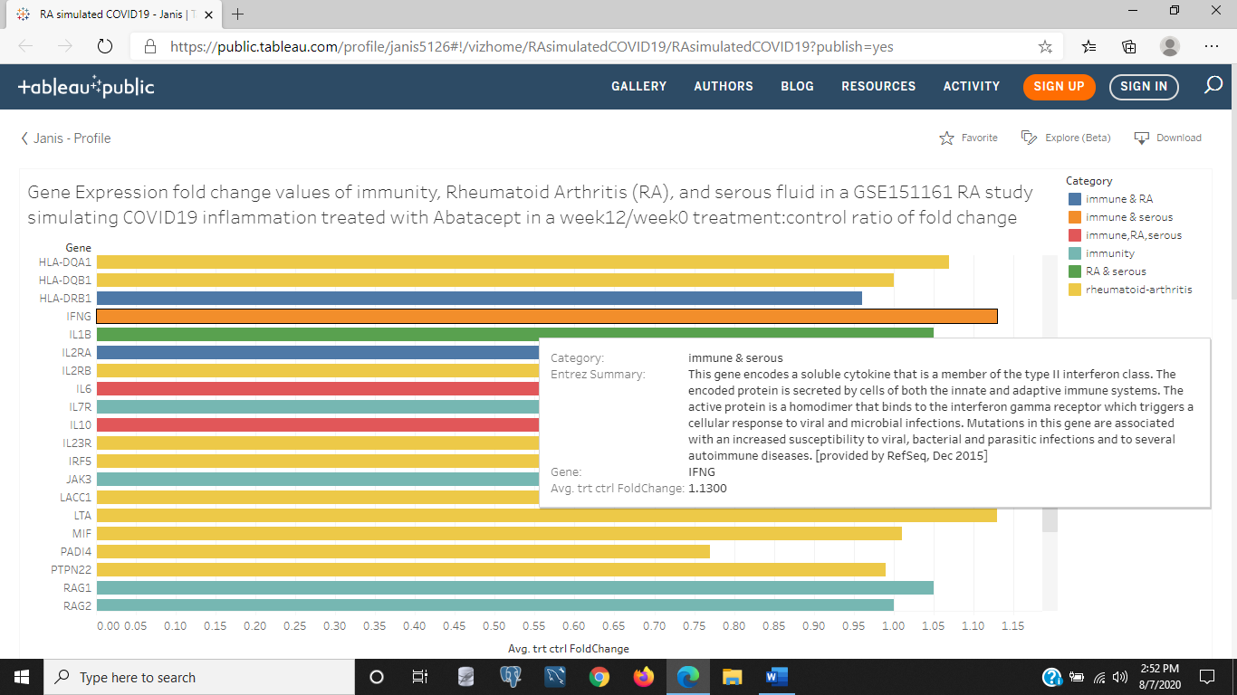

Figure 1b: The above screen shot shows one of the RA and serous fluid genes, IFNG, with an increase in gene expression on average over 12 weeks by 13% in fold change values of week 12/week 0 ratio. This gene is a soluble cytokine that triggers a defense response to viral and bacterial infections. Mutations in IFNG lead to susceptibility infection in patients with autoimmune disorders and bacterial, parasitic, or viral infections.

<https://public.tableau.com/profile/janis5126#!/vizhome/ageRAsimulatedCOVID19/ageRAsimCOVID19?publish=yes>

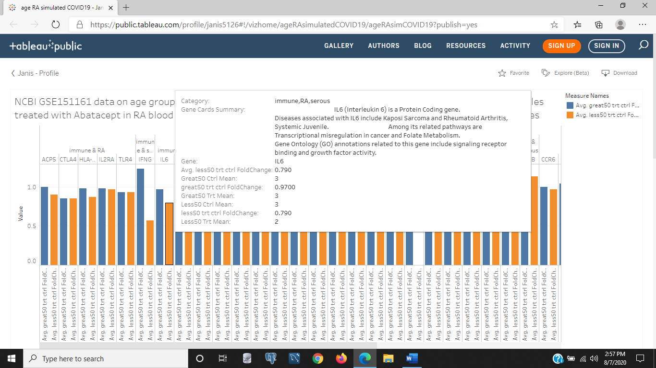

Figure 2a: In the above image, IL6 is also decreased in this Tableau bar chart for RA patients younger than 50 years of age with a 21% decreased gene expression in fold change of the ratio of week 12/week 0. This bar chart compares the treatment to control with the two age groups of those younger than 50 years old and those older than 50 years old.

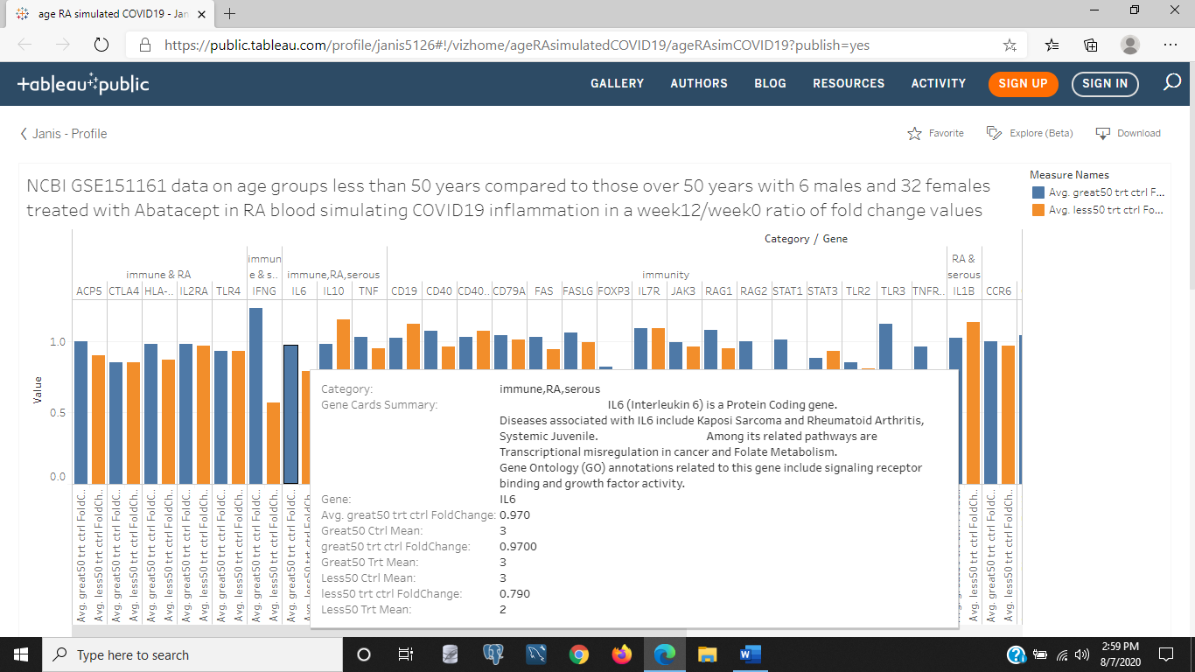

Figure 2b: The above image is also of the bar chart in Figure 2a, except it shows the IL6 gene expression for the group of patients older than 50 years old. The fold change of the ratio of week 12/week 0 is decreased by 3%, which is less than not being treated with Abatacept. IL6 shows an over all decrease in gene expression over 12 weeks compared to the first week with the use of Abatacept, but patients younger than 50 years old show a decrease of 18% more in 12 weeks compared to the first week.

<https://public.tableau.com/profile/janis5126#!/vizhome/genderRAsimulatedCOVID19/genderRAsimCOVID19?publish=yes>

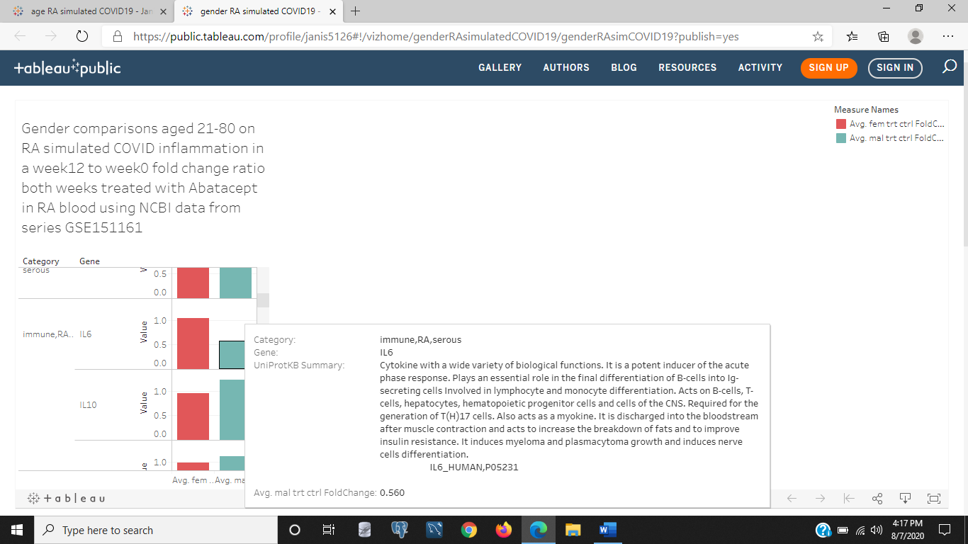

Figure 3a: The above image is of the Tableau bar chart of the gender comparison of males versus females in gene expression fold change values of week 12/week 0. In the above image, the males are the blue bar, and for IL6, after 12 weeks and having been given Abatacept to slow IL6 (a painful inflammatory considered the cause of lung inflammation in COVID-19 patients) there was a decrease by 44% in IL6 gene expression for all males in this study of treatment to control.

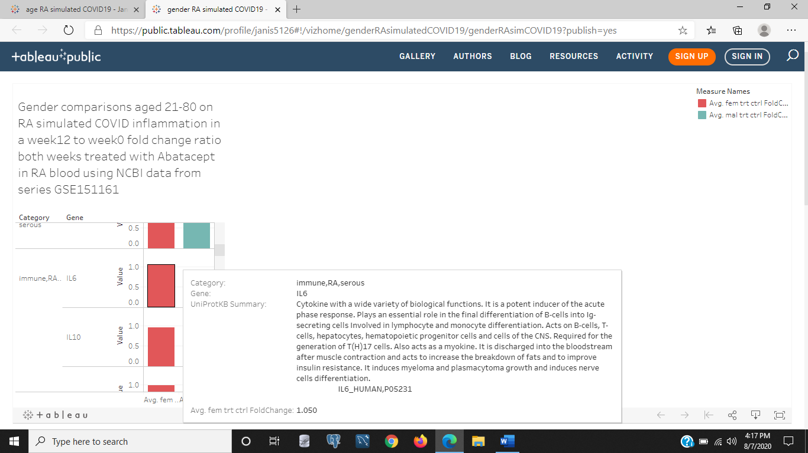

Figure 3b: The above image is of the same bar chart comparing gender groups in Figure 3a, but the females are hovered over the IL6 gene. The details for the red bar indicating females in the chart for gene IL6 shows an increase in IL6 by 5% overall females in the group study on Abatacept given in Week 0 and in Week 12. It looks like females have an overall slower decrease in the autoimmune body response of inflammation and pain than the males. This does include all females in the study, as does the males group. And that age range is 21-80 years old.

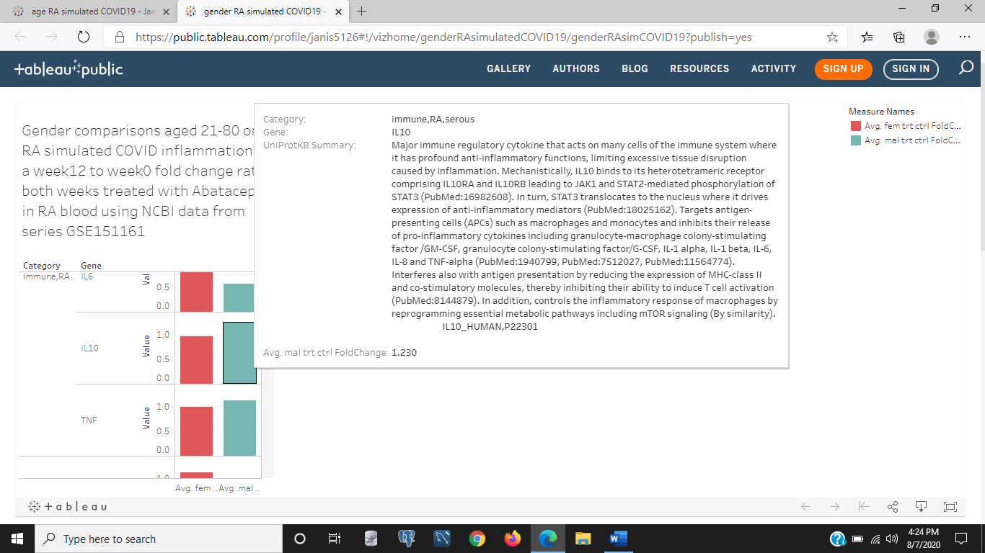

Figure 3c: If we look at another interleukin just below IL6, we see that males have more IL10 production than females, and this gene is an inhibitor of interleukins like IL6 and other antigen presenting cells (ACPs) like macrophages and monocytes. This would make sense for why there is far less gene expression in males of IL6 than for women.

<https://public.tableau.com/profile/janis5126#!/vizhome/log2age50plusRAmeans/log2age50plusRAmeans?publish=yes>

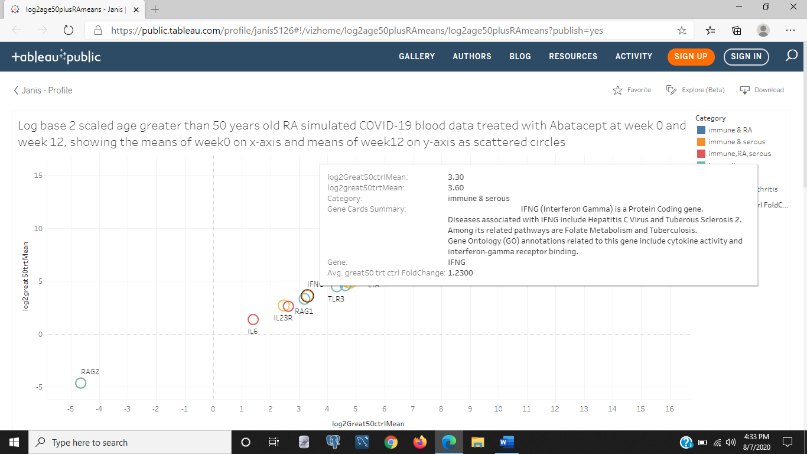

Figure 4a: The above is a scatter plot of the patients older than 50 years old with treatment (week12) to control (week 0) of the log2 scaled mean sample values in the Tableau chart. The different body system and disease category of the gene is the color indicator, and size of the scatter points are the fold change values of the week 12/week 0 gene expression values. There is only some slight variations in the gene expressions after 12 weeks, with the gene having the most fold change increased by 23% for IFNG. This is an interfeuron associated with tuberculosis and hepatitis C.

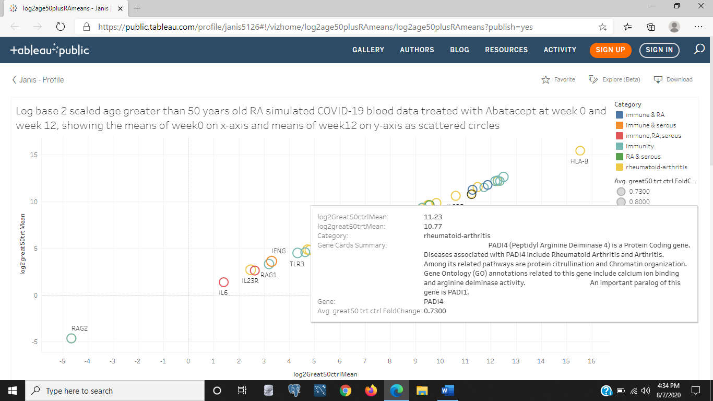

Figure 4b: The above image is the same chart as Figure 4a, but it shows the most gene expressed in week 12/week 0 fold change in decreasing by 27% for an RA gene, PADI4. The decrease in this gene associated with RA shows that Abatacept helps reduce the gene triggering autoimmune responses in its RA patients.

<https://public.tableau.com/profile/janis5126#!/vizhome/log2femalesRA-COVID19/log2femalesRA-COVID19?publish=yes>

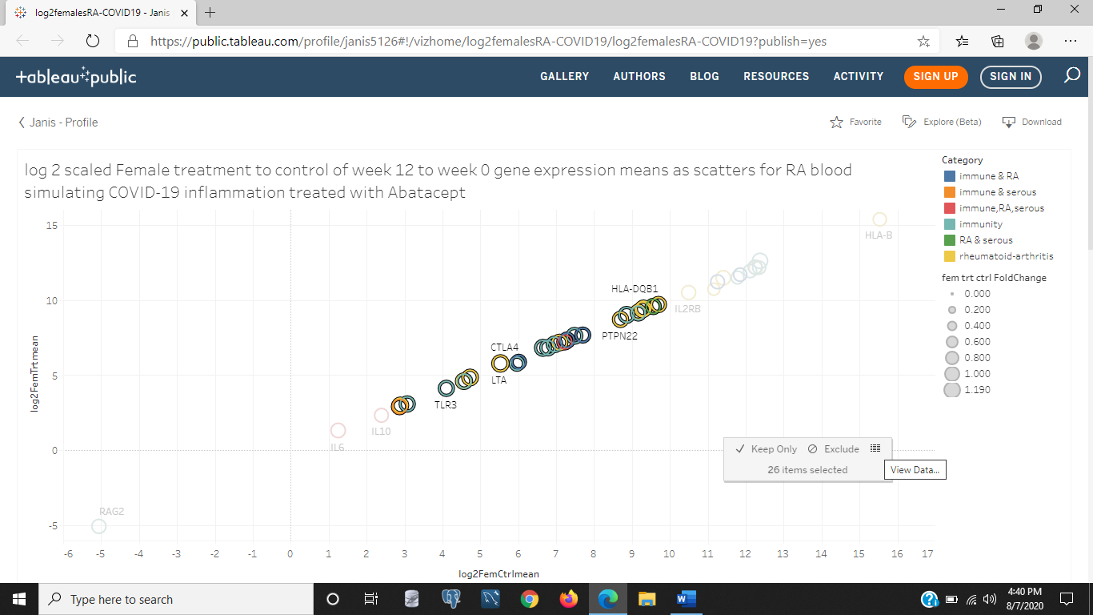

Figure 5a: The above is some highlighted scatter plots that pops up a window that allows the user to view the underlying data to see the tabular form of those scatter points for more information by selecting to far right 'hamburger' icon I have heard it called (the 3 lines in a square). This data is the female treatment to control results for week 12/week 0 of receiving Abatacep.

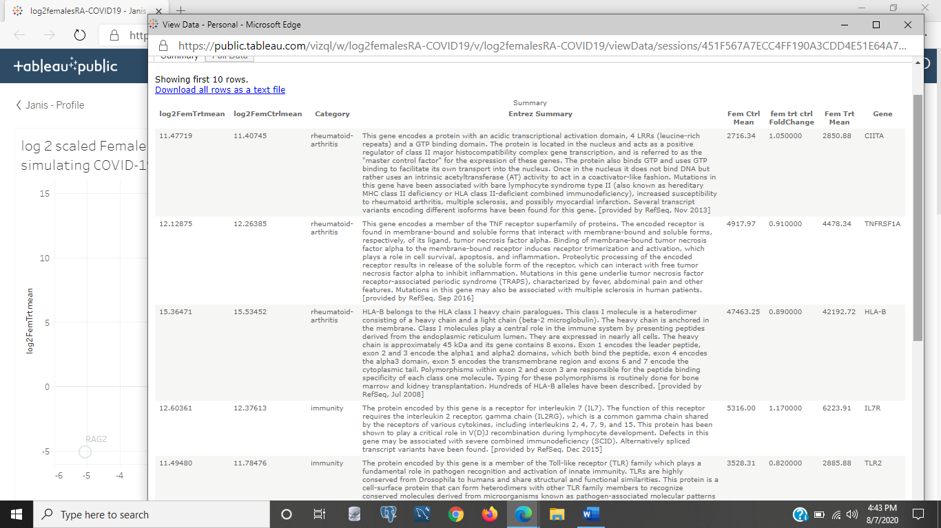

Figure 5b: The above image shows the results of selecting the hamburger icon to view the data when selecting the scatter points on the interactive Tableau chart. This data is the same chart in Figure 5a and the next figure 5c. The females treatment to control fold change values are displayed to scroll through and find more information on genes that changed, what they do and which ones changed the most after 12 weeks.

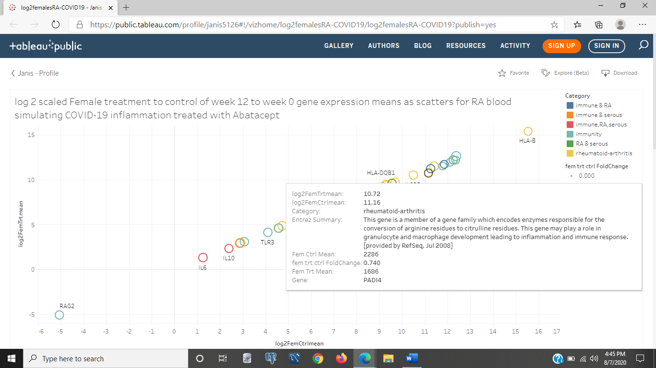

Figure 5c: The above image is the same screen shot of the scatter plot in Tableau of the log2 scaled female fold change gene expression values for week 12/week 0. But the RA gene that was shown decreased significantly in patients older than 50 years old is shown to also decrease by 24% in females after 12 weeks using Abatacep.

<https://public.tableau.com/profile/janis5126#!/vizhome/log2MalesRA-COVID19/log2malesRA-COVID19?publish=yes>

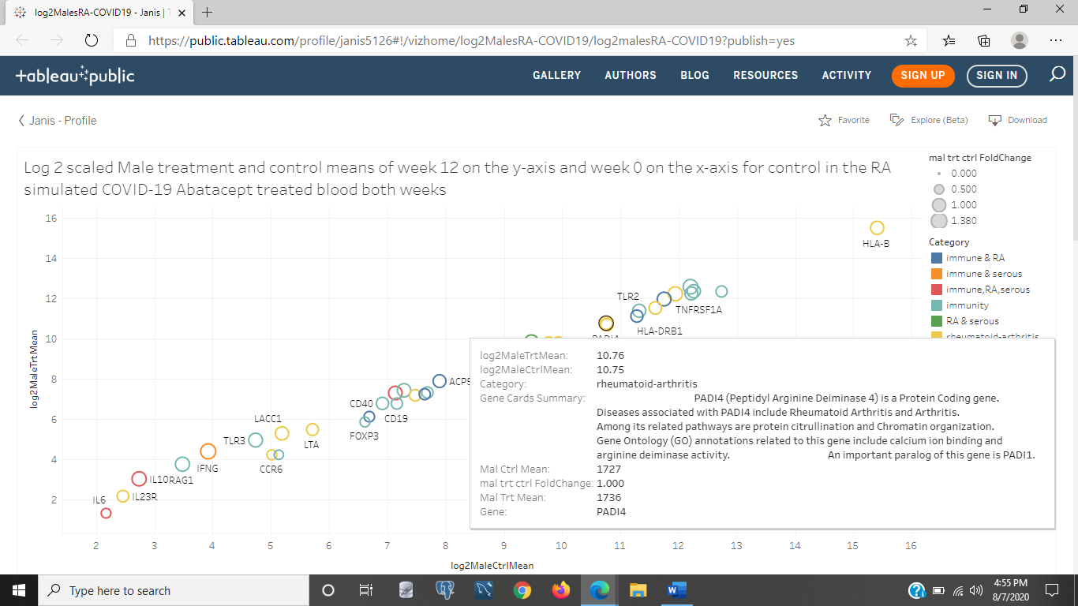

Figure 6a: The above image is a screen shot of the Tableau scatter plot for the male group of treatment to control of week 12 to week 0. For the males, the RA gene PADI4 stayed the same after 12 weeks as it was in week 0. However the male's IL6 went down dramatically more than the patients older than 50 and the females for whom the PADI4 RA gene decreased significantly. We also see there is more skew or variation from the imaginary line going through all the scatter points. This isn't a regression, so we can't call it a regression line. This means the male group had more changes after 12 weeks than at week 0 for some genes. A more noticeable amount than for the other subset groups by age and the females.

<https://public.tableau.com/profile/janis5126#!/vizhome/log2MalesRA-COVID19/log2malesRA-COVID19?publish=yes>

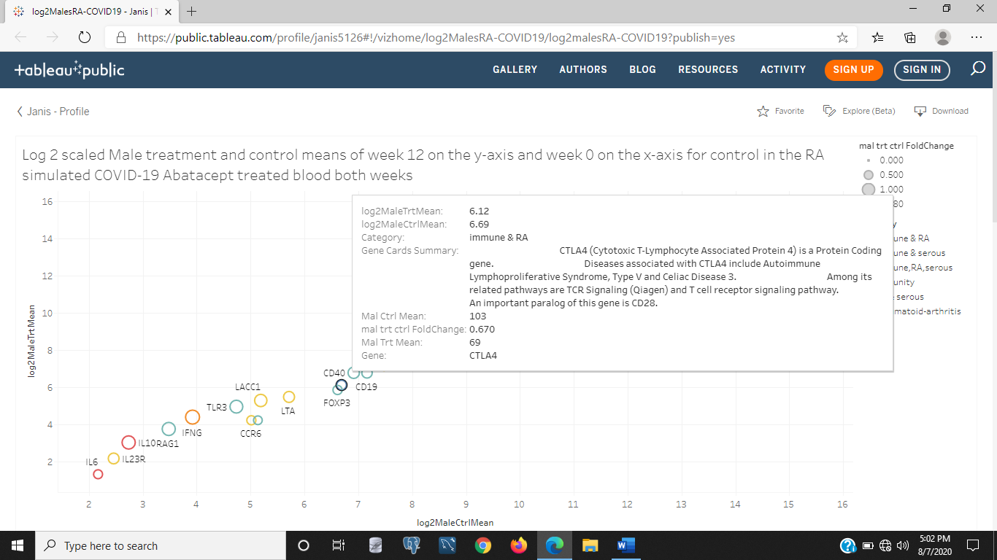

Figure 6b: One gene that is decreased is a T-cell signaling pathway gene called CTLA4, that decreased by 33% in week 12 compared to week 0 in fold change gene expression values of treatment/control with Abatacept. The above image is the same scatter chart of males mean gene expression values as Figure 6a.

Later additions to this blog will show some machine learning to predict how accurate our data is of taget genes in these groups at predicting the category of the gene as immunity, RA, serous fluid, or some combination, or if the case is a male or female, or if the case is a person under or older than 50 years old, by selecting the best genes with more variation or fold change as genes to split the 76 samples of 38 of the same patients in the control at week 0 and in the treatment at week 12. For now, it was interesting to see how inflammation caused by COVID-19 is suggested to slow down by using an RA drug that helps elderly and females with autoimmune disorders in lowering the cytokine responsible for that inflammation, IL6. The Abatacept seems to actually boost the males response and use of their own immune system to inhibit production of IL6 by boosting production of natural inhibitors like IL10 and CTLA4 that blocks the T-cell or thymus killer cells activating the inflammation response in the body to antigens.

Feel free to explore the charts in this blog at my Tableau Public Server link. Each image links to the chart. Stay healthy, exercise, get enough sleep, wear your face masks, and get regular massages and stretch regularly to keep your immune system at its best, and also wash your hands and use sanitizer. COVID-19 is still a major pandemic and my own massage studio I work as an employee is currently on the 2nd wave of quarantines on service businesses that cannot operate outdoors. If you want a mobile massage and are in the Corona area, as long as you have a doctor's note prescribing you massage for your health, don't have a contagious condition or any condition listed in the contraindications section of www.themassagenegotiator.com or if you don't mind getting massaged outdoors and have enough room and protection from the sun and bugs, then please schedule your next massage with Janis.